ROBUST METHODS FOR TUNING PID CONTROLLERS
Juraj Kalman and Ondrej Siták
Slovak University of Technology, Faculty of Electrical Engineering and Information Technology
Ilkovičova 3, 812 19 Bratislava, Slovak Republic
Tel.: +421 7 60291111 Fax: +421 7 60291111
e-mail:kalman,sitak@kasr.elf.stuba.sk

Abstract
The paper deals with a novel approach to PID controller parameter design for cascade control configuration. The proposed method applies an IMC-based system approach to the controller design and computation of its parameters.
Keywords: PID controller, cascade control, robust IMC approaches, control of chemical plants

INTRODUCTION AND PRELIMINARIES
Cascade control belongs to the most efficient methods to improve performance quality in single loop in presence of unknown disturbances and noise or the controlled variable is nonlinear. Cascade control is therefore widely applied in power systems, heating, in chemical plants. It is well known that the performance quality in cascade control configuration depends on parameter tuning in each loop (Rivera,1986). Recent methods for cascade control parameter design prefer conventional approach based on analysis and design in frequency domain. These conventional approaches use two-step design of control parameters. This paper presents a new approach of cascade PID controller design.

PROBLEM STATEMENT
We consider the following PI controller
$u\left(t\right)=K\left[e\left(t\right)+\frac{1}{T_{i}}\int_{0}^{t}{e\left(t\right)\text{dt}}\right]$ (1)
in Tab. I the controller parameters are given.
Table I. Parameter values
Controller type | P | I
Value | 1 | 0.5

Secondary controller must be designed to stabilize the inner control loop and compensate for unknown disturbances and noises in the inner loop. The output controlled variable in the secondary control loop must follow the reference input sufficiently fast without overshoot and oscillations. This requirement can be met if the secondary controller is designed so that the time response (reference input tracking) is stable and well dumped.

EXAMPLES
Simulation of cascade control scheme is realized in MATLAB. The resulting responses are shown in Fig.1.

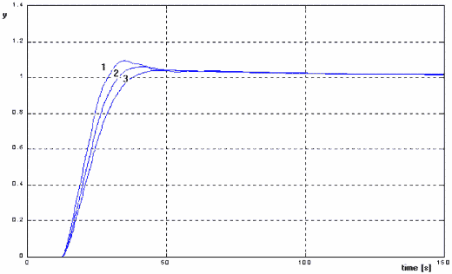
Fig. 1. Closed-loop step responses

CONCLUSION
The main advantages of the proposed cascade control design scheme are listed below:
- simple and user friendly, since parameter tuning rules are in analytic form,
- design of controllers in the inner and outer loop is simultaneous since the proposed method is based on plant model parameters,
- the cascade control system can be designed with respect to both loop specifications since the proposed method has two free parameters.

REFERENCES
[1] Vesely J.: Dynamic systems. Trans. JSCM, 30, 1997, 97-135
[2] Pisko M.: Linear and nonlinear models. Trans. JSCM, 29, 1996, 35-42

